Post-Event Report

Pakistan–Russia Eurasian Forum 2025
“Forging Connectivity and Exploring People-to-People Partnership for a New Era”
Dates: 16–17 December 2025
Venue: University of World Civilizations (UWC), Moscow, Russian Federation
Time: 10:30 AM – 5:00 PM

1. Background and Objectives
The first Pakistan–Russia Eurasian Forum 2025 was successfully held in Moscow on 16–17 December 2025 at the University of World Civilizations (UWC). The Forum was jointly organized by the Zhirinovsky University of World Civilizations, Consortium for Asia-Pacific and Eurasian Studies (CAPES), and the Federal Urdu University of Arts, Science & Technology (FUUAST), Islamabad.
The primary objective of the Forum was to strengthen Pakistan–Russia relations through public diplomacy, academic dialogue, and people-to-people engagement, with a particular focus on non-traditional security, regional connectivity, economic cooperation, and youth and cultural exchanges within the broader Eurasian context.

2. Participation and Representation
The Forum brought together a wide spectrum of stakeholders, including:
- Senior diplomats and ambassadors from Pakistan and Russia
- Policymakers and legislators
- Academics and researchers from leading universities and think tanks
- Media professionals, students, and civil society representatives
Key participation included senior officials from the Russian Ministry of Foreign Affairs, the Embassy of Pakistan in Moscow, Russian Ambassador to Pakistan university leadership, and leading scholars from both countries.

3. Opening Session and Key Messages
The opening session emphasized the growing relevance of public diplomacy and academic cooperation in contemporary international relations.
- Ambassador of Pakistan to the Russian Federation, Faisal Niaz Tirmizi, highlighted the increasing convergence between Pakistan and Russia on regional connectivity, trade, and people-to-people relations, describing the Forum as a reflection of pragmatic cooperation in Eurasia. He underscored the symbolic significance of 16 December, recalling shared experiences of terrorism in both countries and reaffirmed Pakistan’s commitment to peace, stability, and counter-terrorism cooperation. He highlighted that Pakistan and Russia are building connections through their youth and research communities.
- Russian Ambassador to Pakistan, Albert P. Khorev (online), emphasized that Pakistan–Russia relations have entered a new dynamic phase, where public diplomacy, academic exchanges, and expert networks form the backbone of bilateral engagement. .
- Ambassador Alexey Pavlovsky, Director of the Second Asian Department, Russian Ministry of Foreign Affairs, highlighted the potential for expanding bilateral trade, including the need for reliable financial and settlement mechanisms, and noted Russia’s interest in cooperation between Pakistan and the Eurasian Economic Union (EAEU).
- Prof. Dr. Zabta Khan Shinwari, Vice Chancellor of the Federal Urdu University of Arta, Science & Technology (FUUAST), emphasized that Eurasian connectivity is a vital pathway for shared progress and prosperity, particularly in higher education and research collaboration. He said that higher education serves as the catalyst for increased connectivity in the Eurasian region and invited Russian students to study at Pakistani universities.
- Prof. Oleg Slobotchikov, Rector of the University of World Civilizations, underscored the need for building a new, sustainable model of international cooperation rooted in dialogue, education and civilizational understanding. He highlighted that the old geopolitical order has ended and commended the increasing ties between the youths of Russia and Pakistan. Both nations share unique cultural values, which serve to unite us.

4. Keynote Address and Strategic Outcomes
The keynote address was delivered by Senator Mushahid Hussain Syed, who framed Pakistan–Russia relations within the broader transformation of the global order.
Key points included:
- The shift of global power from West to East, with Eurasia emerging as the centre of gravity of the Global South
- Pakistan and Russia are strategic partners with no fundamental conflict of interests.
- The necessity of Eurasian multilateralism involving Pakistan, Russia, Central Asia, Turkey, and Iran
- The formal announcement of the Eurasian Connectivity Forum as an institutional platform focusing on:
  - Counter-terrorism
  - Trade, energy, and economic cooperation
  - Education, culture, and media
  - People-to-people connectivity
He also called for an annual Pakistan–Russia Strategic Dialogue led by opinion leaders, academics, and business communities.

5. Thematic Sessions
The Forum was conducted through four thematic sessions over two days, moderated by Dr. Roxolana Zigon, co-organizer of the Forum and Director of the Scientific Center for International Research at UWC.
The sessions addressed:
- Russia - Pakistan Cooperation in a Non-Traditional Security Domain
Dr. Maria Sultan, highlighted the military connectivity between Pakistan and Russia, specifically joint military exercises as well as joint counter-terrorism activities. She emphasized the importance of protecting the identity of nations at home and abroad. Talking about human security, she noted that states need to protect economic security, health security, and prevent discrimination due to identity. She also noted that in the coming era, the digitization of human security would present a significant challenge.
Leonid Savin, underscored the importance of enhancing ties between Pakistan and Russia. He also highlighted the changes in the international environment, such as the emerging multi-polarity, the re-election of President Donald Trump in the US, as well as Russia’s special military operation in Ukraine. He provided the possibility of Russia mediating between Pakistan and India. He also stated that Russia and Pakistan can work together to combat climate change, such as soil erosion and desertification and gave the idea of establishing an Emergency Center in Pakistan. He also advocated for increased labor migration from Pakistan to Russia.

Dr Roxolana Zigon highlighted the expansion of the concept of security away from the traditional understanding of the idea. She talked about the development of new security configurations in South Asia and advocated for increased collaboration between Russia and Pakistan in the non-traditional security domain. She stated that increased Pakistan-Russia ties do not have any hostile intentions, but are a consequence of the changing needs of the two nations, as well as the evolving geopolitical order.
- Socio-Economic Stability — Pakistan-Russia Business Synergy: Expanding Economic Horizons
Ambassador of Pakistan to the Russian Federation, Faisal Niaz Tirmizi, stated that there is a natural connection between Pakistan and Russia. He noted that there is a lot of economic potential between Pakistan and Russia, highlighting the Russian offer to refurbish Pakistan Steel Mills. He also highlighted the potential of tourism and student exchanges for Russians in Pakistan.
Ambassador Andrei Baklanov. noted the unbalanced nature of trade between Pakistan and Russia as well as the difficulties generated by the sanctions. He highlighted that barter trade becomes difficulty due to the varied actors involved in the trade. He stated that the trade between the two countries is too modest and that one of the ways to overcome the unbalanced nature of trade is to include land and property in trade.
- Comprehensive Regional Development & Connectivity
Dr. Maria Sultan, spoke regarding the challenges presented by the weapons left by the US in Afghanistan following its withdrawal in 2021. These weapons are being used by various terrorist groups residing within Afghanistan to commits acts of terror. She also highlighted the role of dug production in the Afghan regime as well as the misuse of humanitarian aid by the Taliban. She advocated for greater oversight of the Afghan aid process, a more inclusive government in Kabul, increased border security for Pakistan, and greater diplomatic engagement with regional and extra-regional allies for the Afghan issue.
Dr. Prokhor Tebin, noted the potential for increased bilateral trade between Pakistan and Russia. He stated that the two countries can expand their cooperation in other arenas as well such as in education, climate change. He proposed that trade countries in the Eurasian region needs to be expanded and diversified and expressed hope that the Pakistan-Russia Forums can continue. He advocated that the countries should move beyond barter economics and trade in local currencies.
Senator Mushahid Hussain, stated that the building blocks of the new global order are multilateralism and multi-polarity. He highlighted that Eurasian connectivity in education, media, counterterrorism and other fields will be the driving force of the Global South. He stated that there should be a regional approach towards Afghanistan in the face of shared challenges. Eurasian Connectivity Forum should act as the institutional framework for increased interaction. He also proposed an Annual Strategic Dialogue between Russia and Pakistan, considering a similar world view as well as no divergent strategic interests.
- Bridges Beyond Borders: People-To-People Cooperation & Expanding Youth Diplomacy
In the final session, Dr. Faisal Javaid emphasized that soft power is essential for transforming Pakistan–Russia relations from state-centric engagement to society-driven partnership, addressing long-standing perceptual gaps between the two countries. He highlighted academic diplomacy, cultural exchange, media cooperation, and youth engagement as core pillars for sustainable people-to-people connectivity. The presentation underscored that soft power complements strategic and economic ties by building trust, familiarity, and long-term societal bonds.
Dr. Shabana Fayyaz noted the role of culture and language as a tool for connection and understanding between two peoples. She highlighted that there are significant opportunities for education exchanges, joint academic programs between Pakistan and Russia. She also admired the role of Pakistani students in establishing ties with their Russian comrades and noted the tourism potential of both nations.
Dr. Irina N. Serenko presented a paper on joint media projects as a tool for strengthening Pakistan–Russia cooperation and noted the role of the Pakistani Business community in expanding Pakistan-Russia bilateral ties. She presented a newly published academic monograph on Pakistan–Russia relations to Senator Mushahid Hussain and Ambassador Faisal Niaz Tirmizi.
Dr. Yuri Samonkin noted the shared Pakistani and Russian presence in forums such as the SCO and that Pakistan is an important strategic and economic partner of Russia. He stated that there is a need for increased dialogue both at the diplomatic level as well as at the grassroots level, i.e. between youth. He highlighted the role of education and IT initiatives as bridges between the two countries. He stated that the two countries should create an online portal to share important documents so as to understand each other’s strategic culture.

6. Media Coverage and Visibility
The Forum received extensive media coverage across Pakistani and Russian platforms, including major television networks, newspapers, digital media outlets, and international news agencies. Live recordings of sessions were broadcast and archived online, significantly enhancing the Forum’s outreach and impact.
- Daily Times
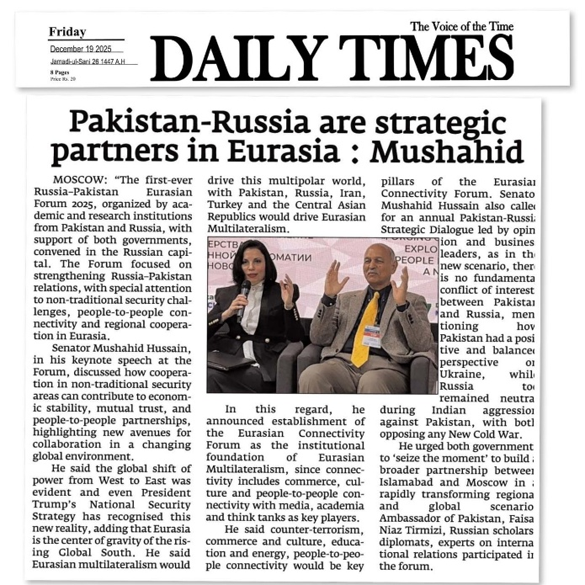
- The Province
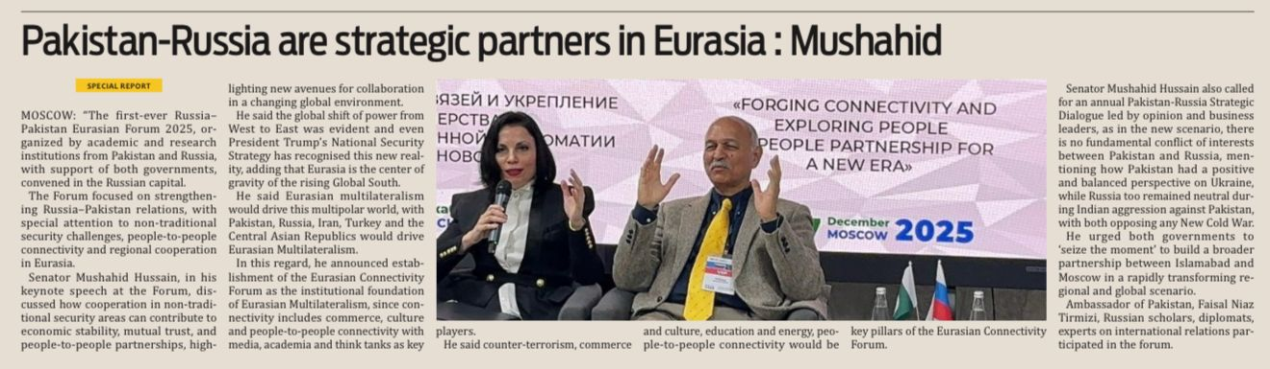
- Islamabad Mail
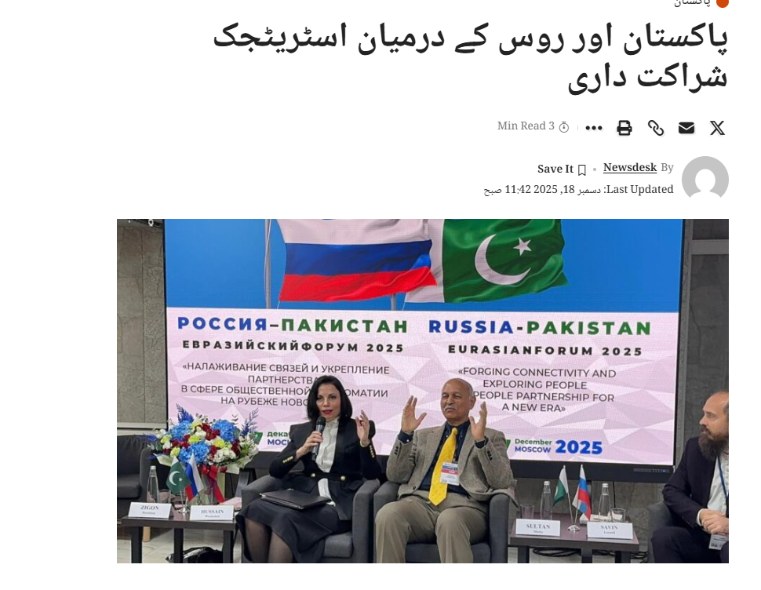
- Daily Graff
- 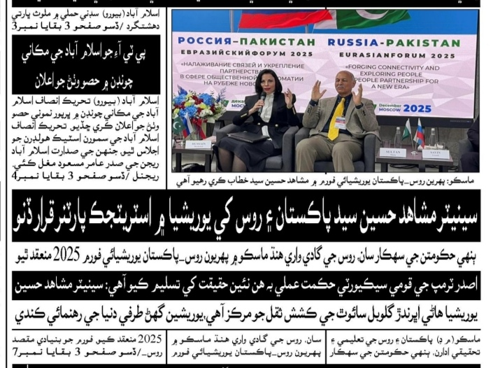

- Jang
- 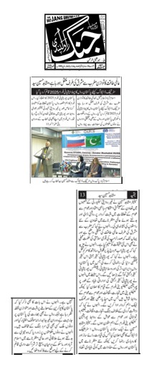

- Daily Pak Sindh
- 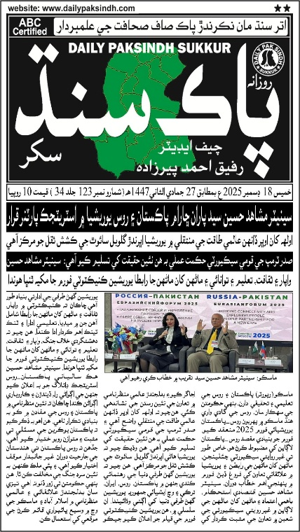

- Commerce News
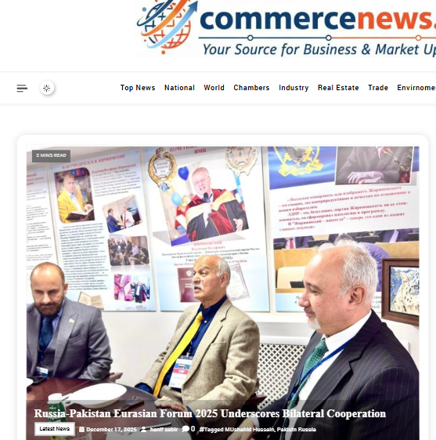
- RIA Novosti

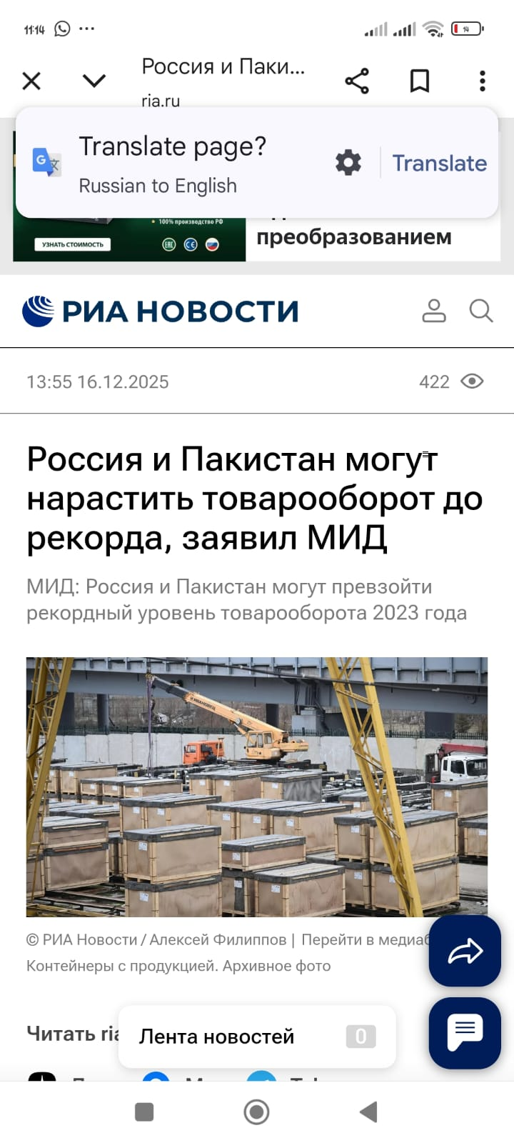
- PTV
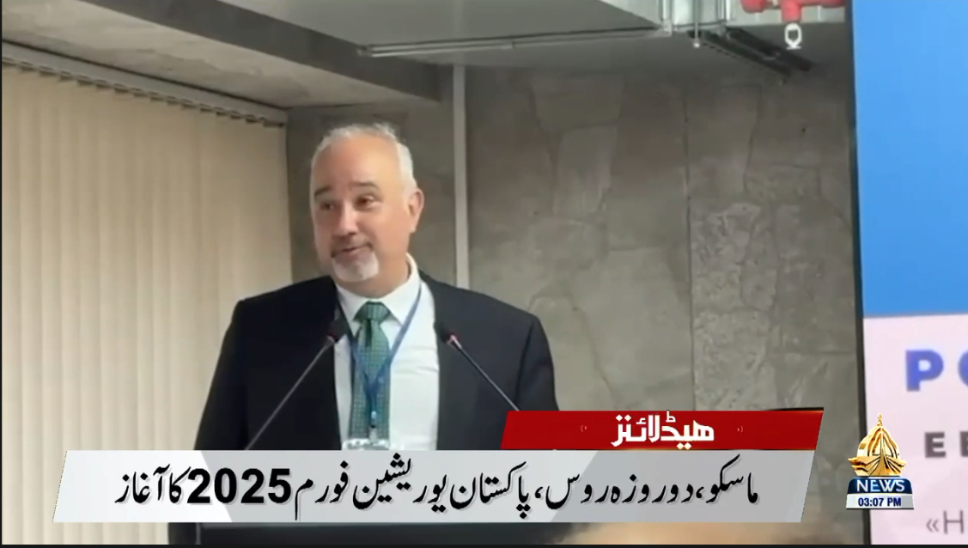
- Express Roznama
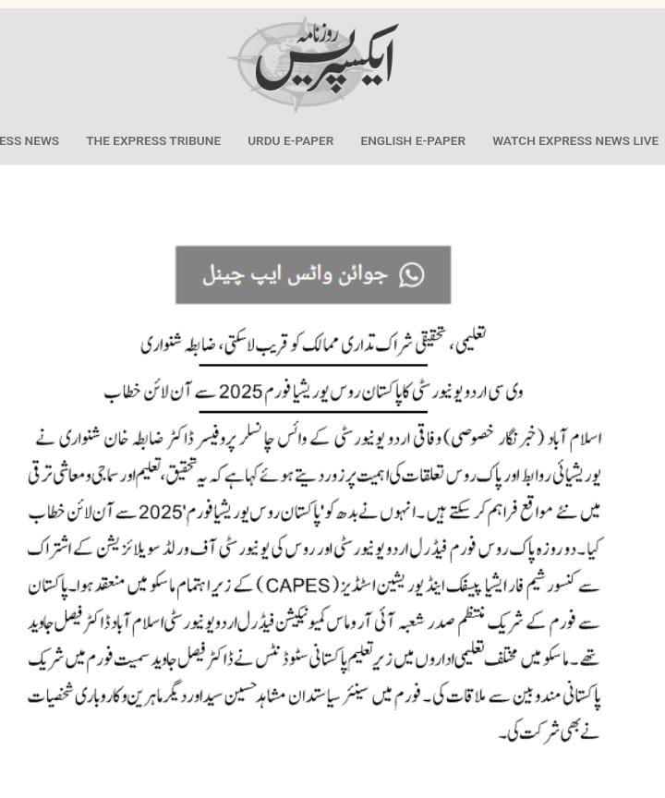

- DND
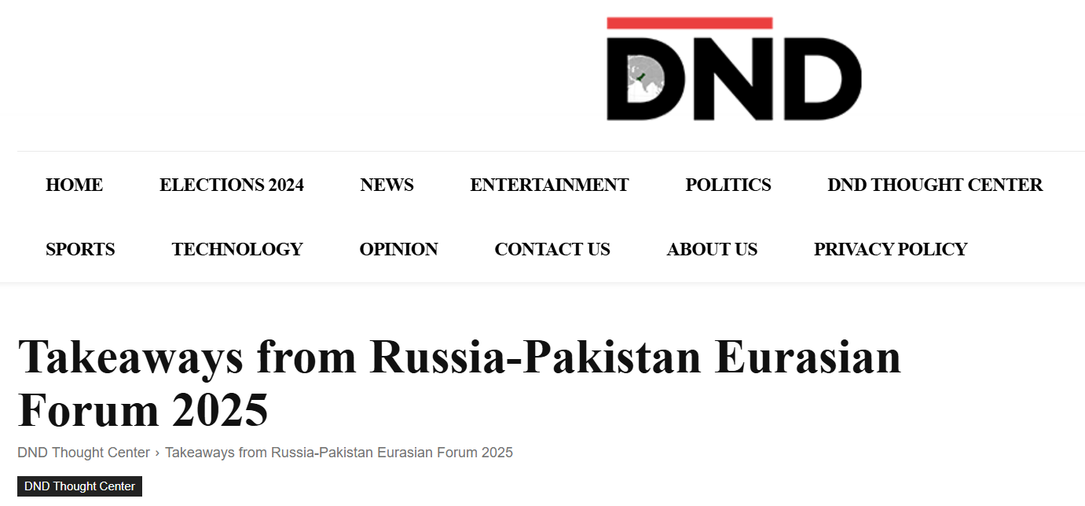
- Geo TV

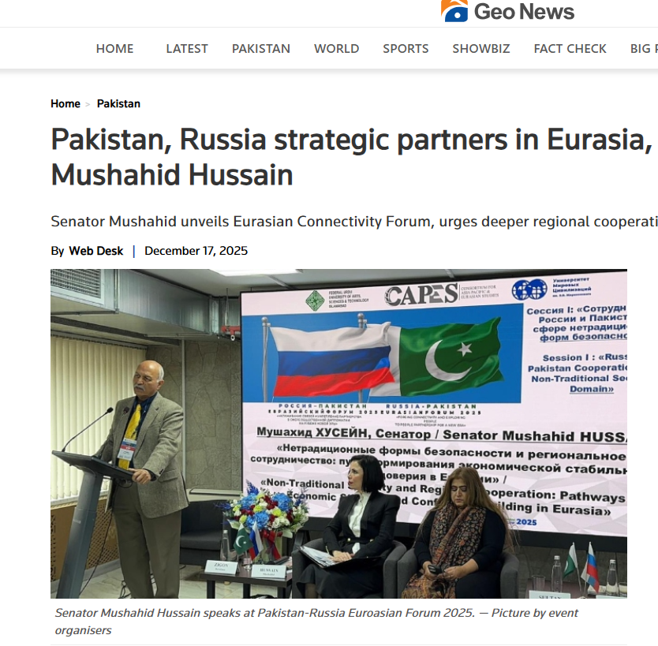
- Associated Press of Pakistan
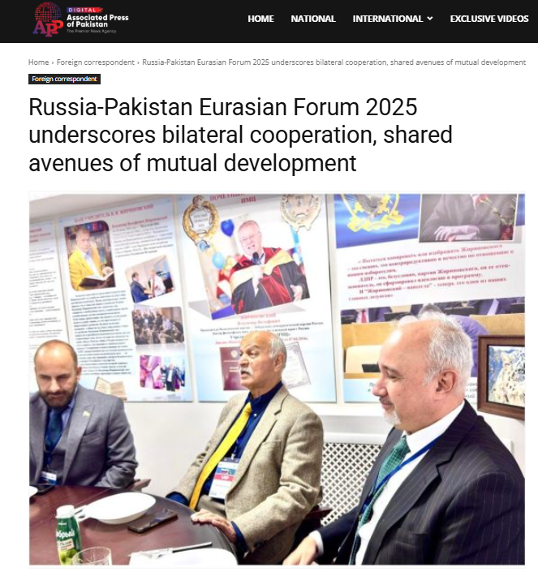
- Express Tribune
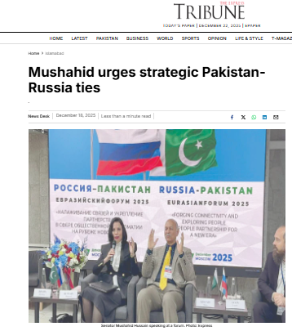
- Pakistan Today
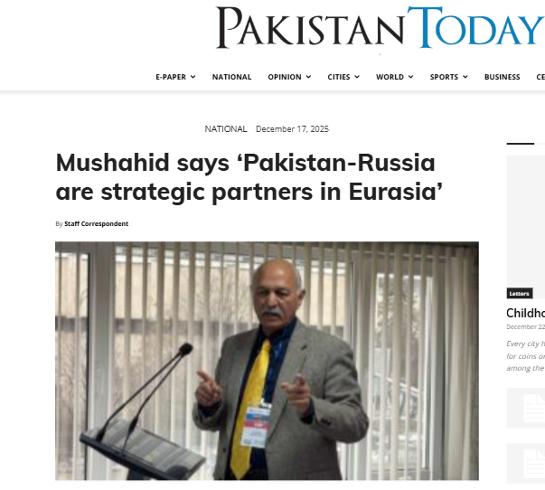
- The Daily CPEC
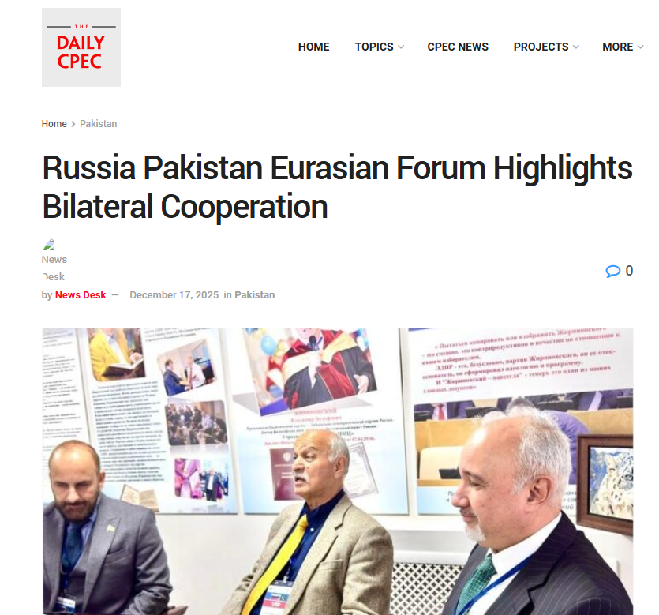
- Zen
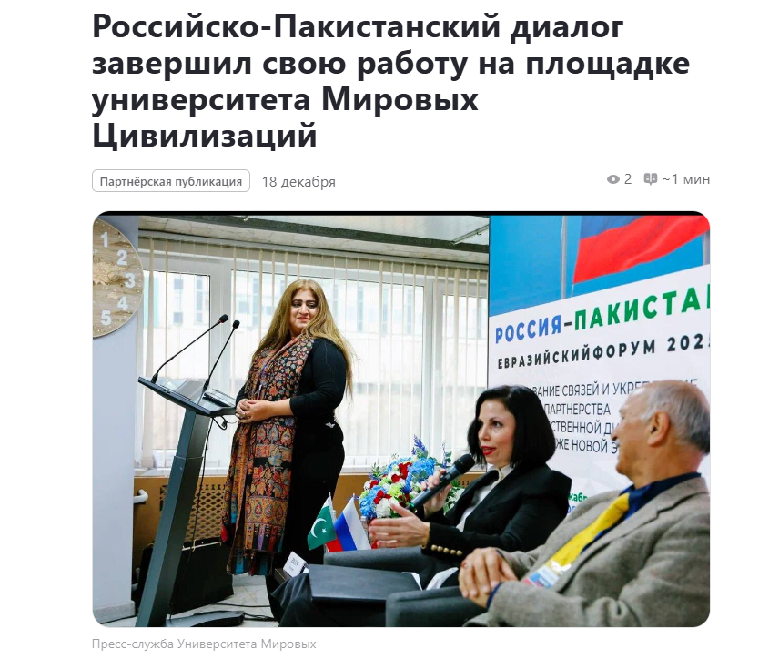
- Voice of Russia

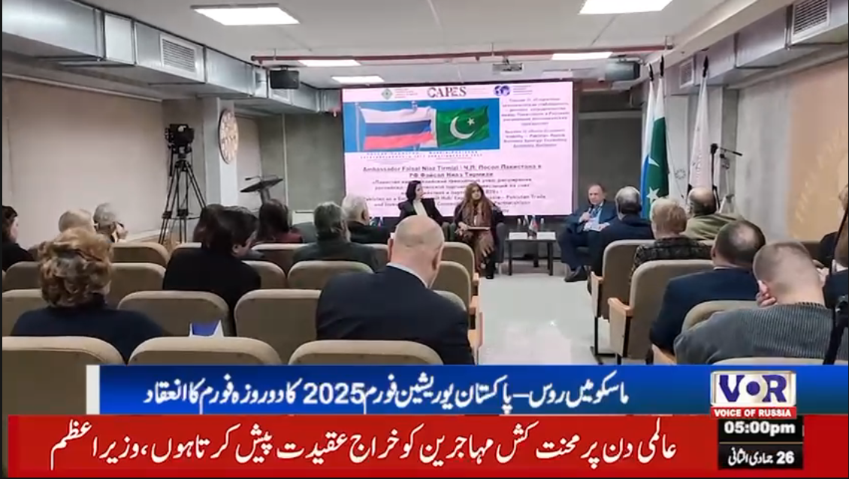
- Dunya News
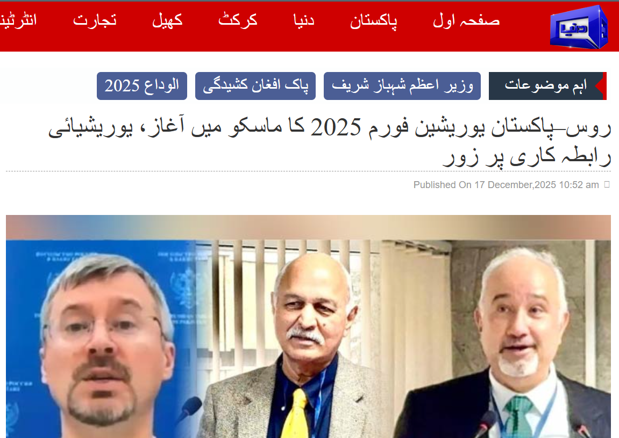
- Sada-e-Rus
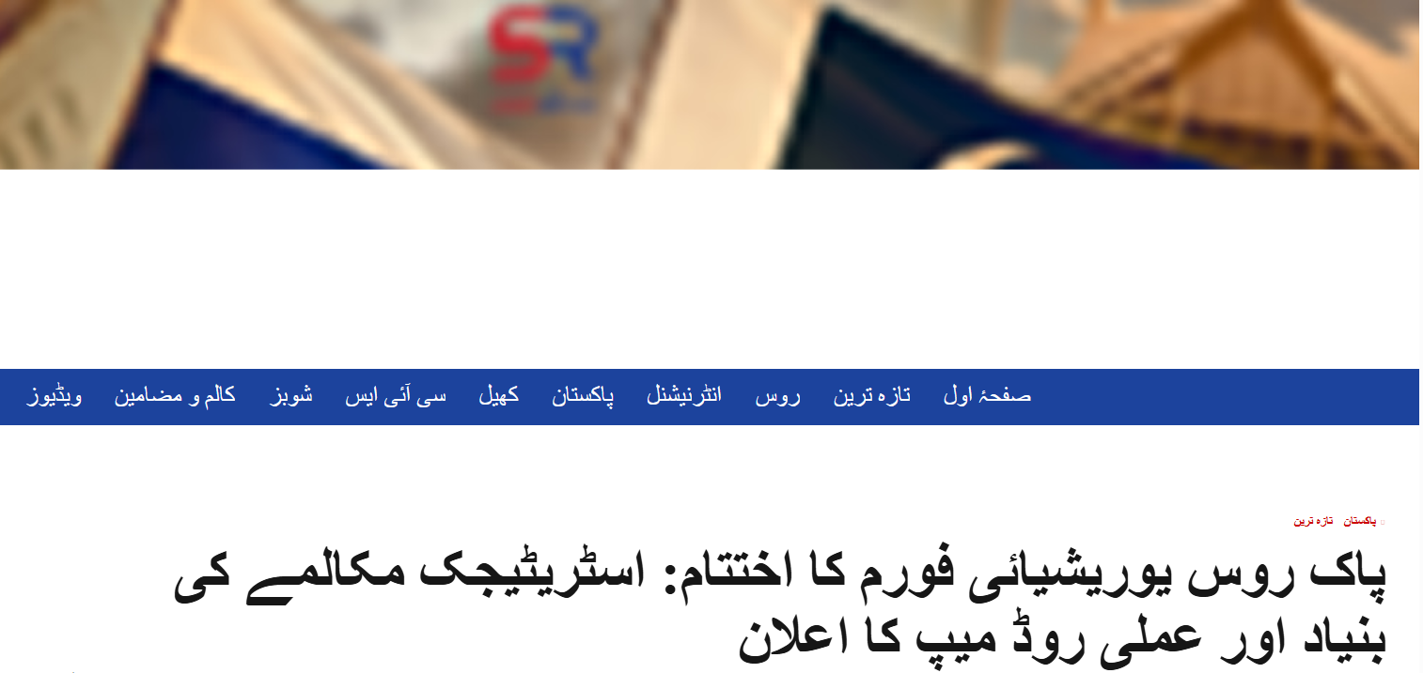
- World Russia
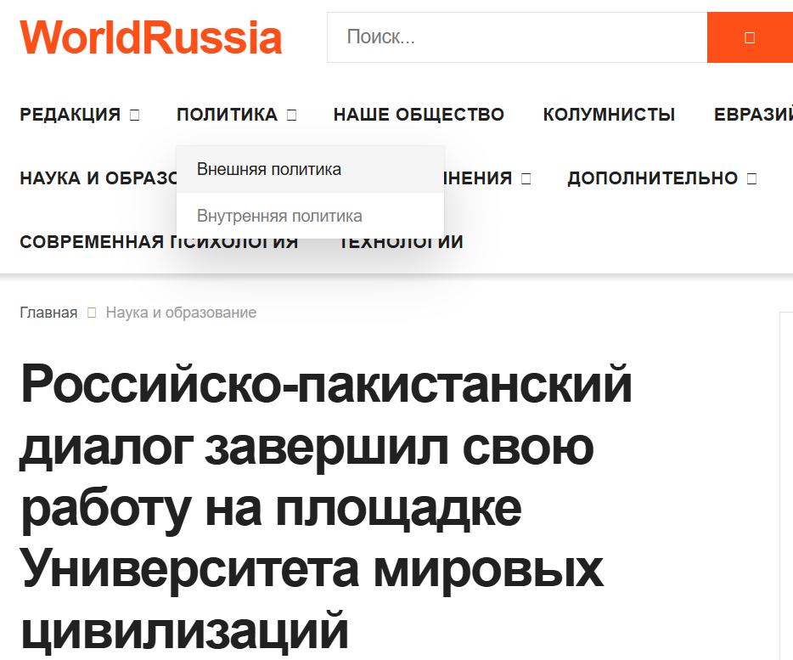
- Sputnik
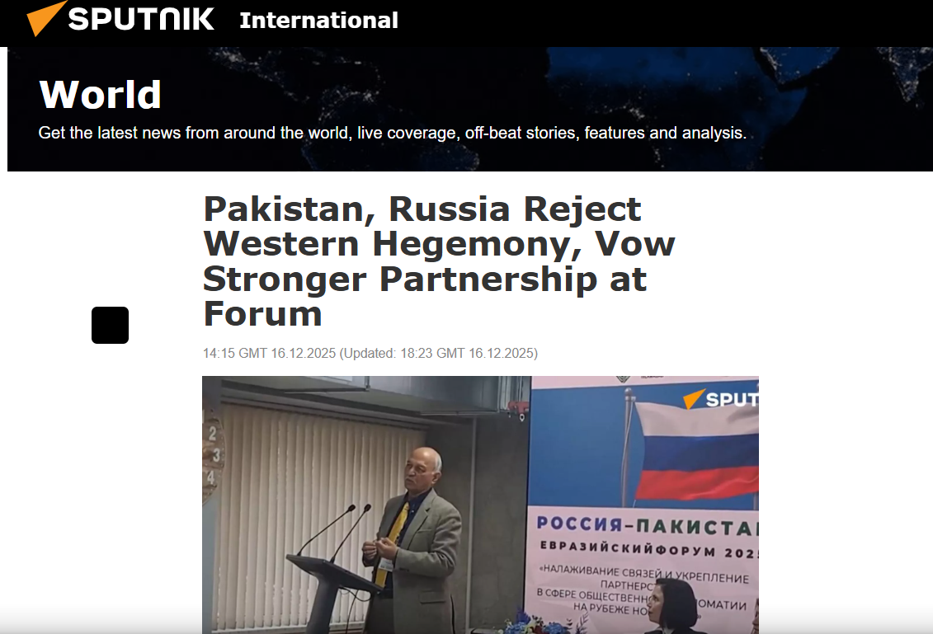
- Shahid Ghumman
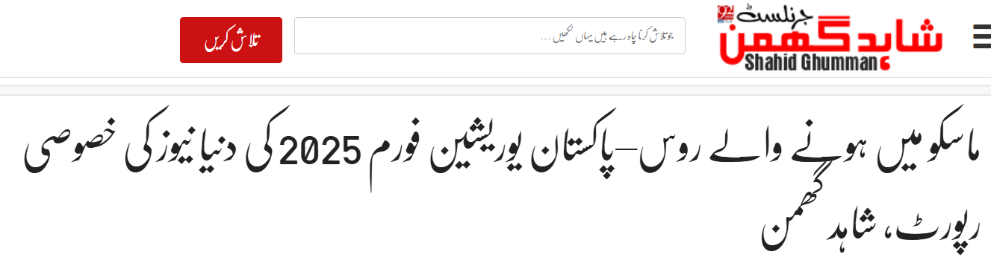
- Independent Press Service
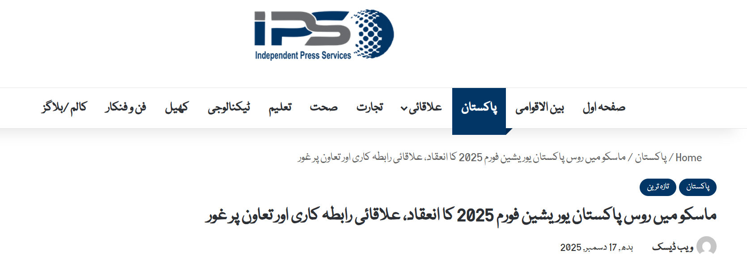
- Daily Sub News
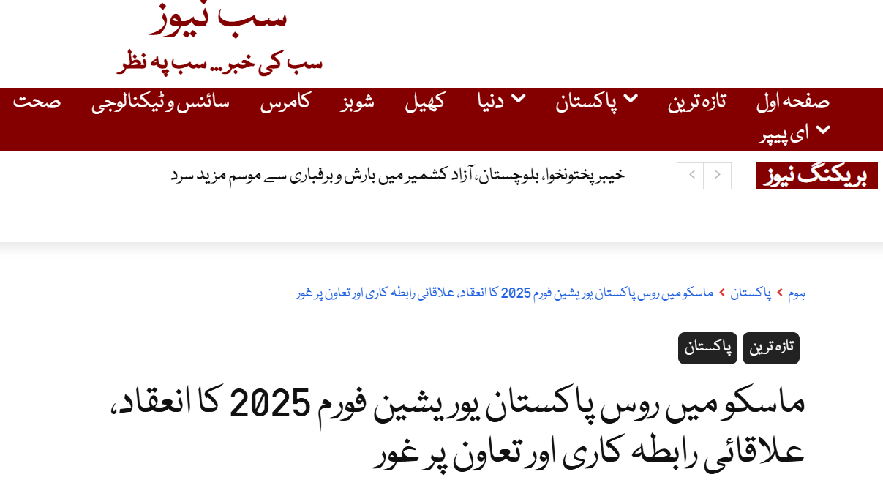
- Daily Sada-e-Chanar

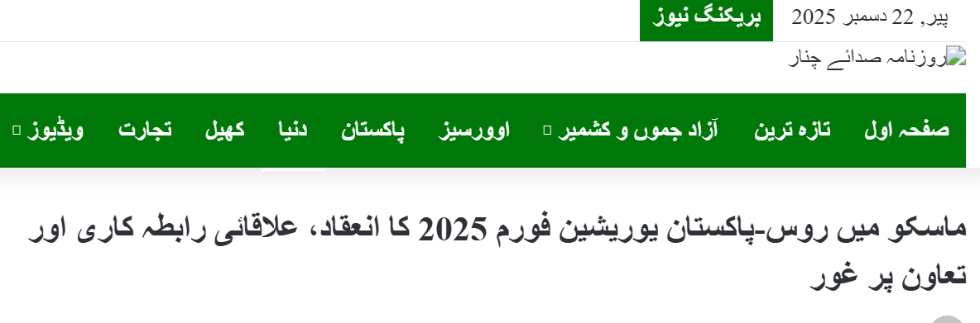

10. Conclusion
The Pakistan–Russia Eurasian Forum 2025 successfully established a new institutional foundation for sustained dialogue, cooperation, and public diplomacy between Pakistan and Russia. It marked the beginning of a structured, people-centric, and policy-oriented engagement framework, positioning both countries as constructive partners in the evolving Eurasian and multipolar global order.
The Forum fulfilled its objectives by transforming dialogue into actionable frameworks, reinforcing trust, and laying the groundwork for long-term academic, cultural, economic, and strategic cooperation.

12. Gallery

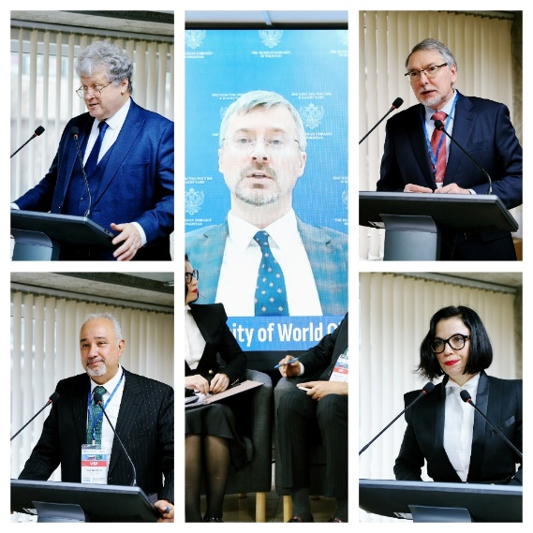

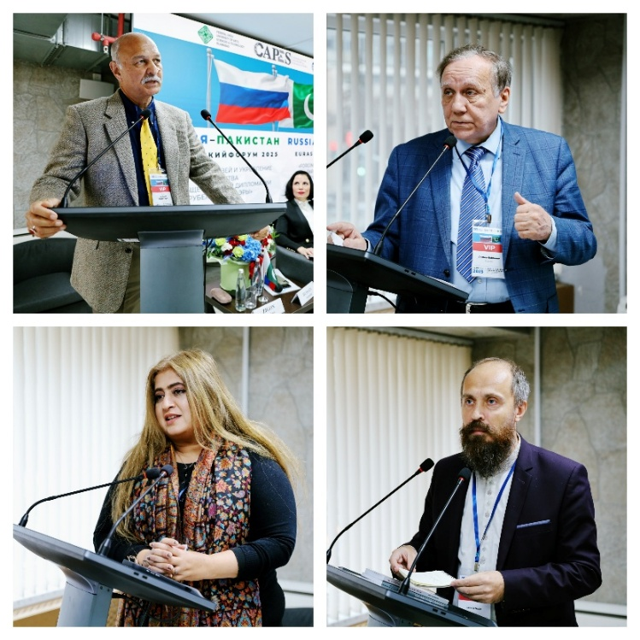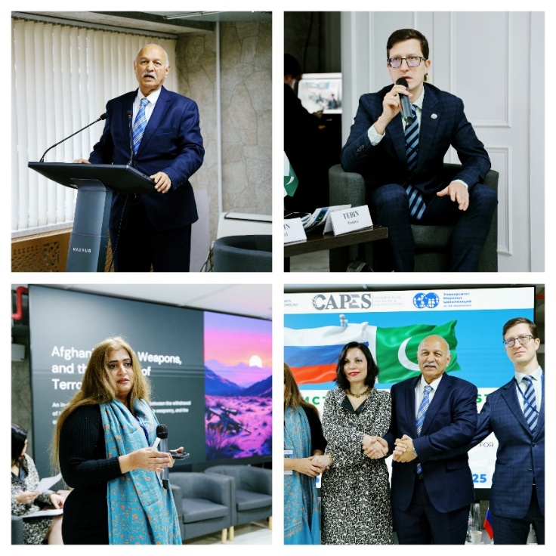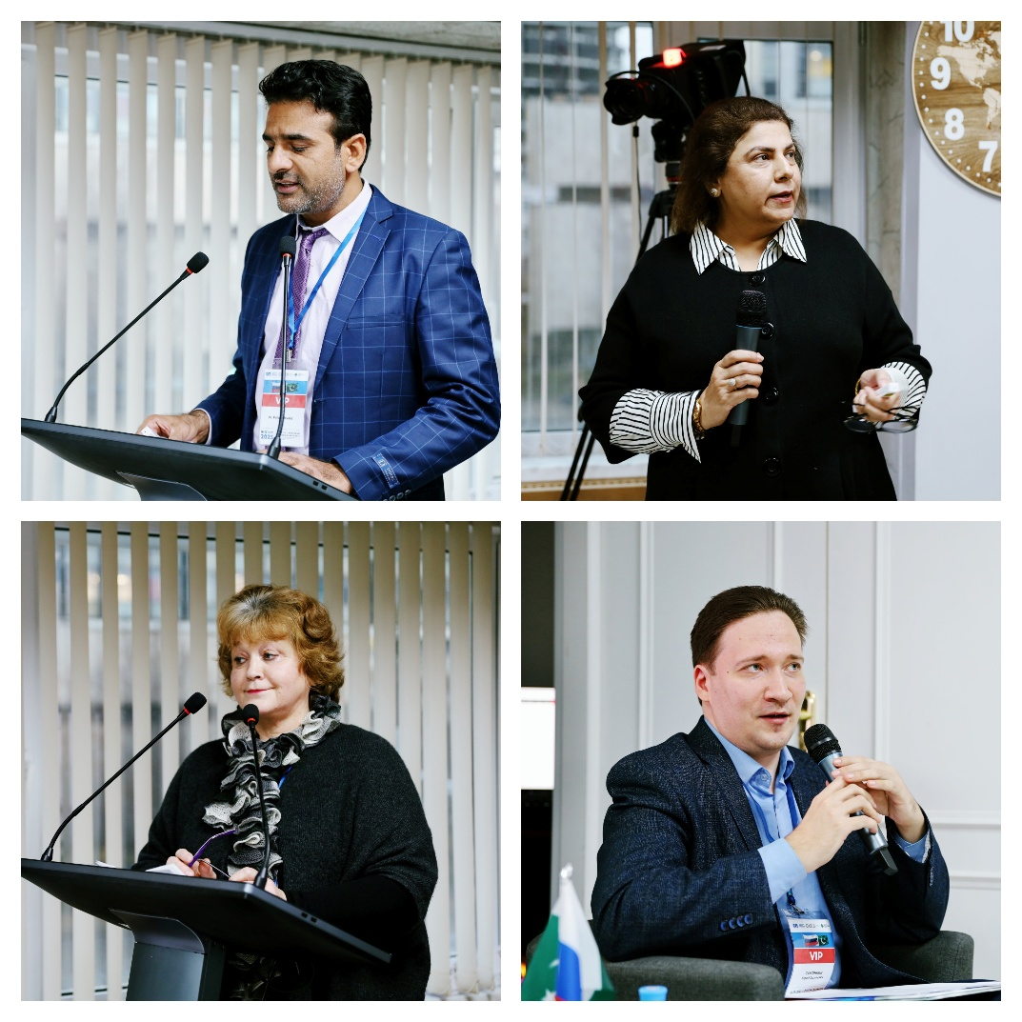

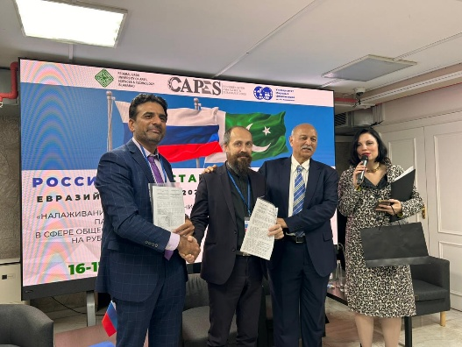
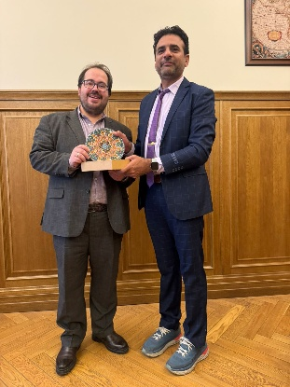
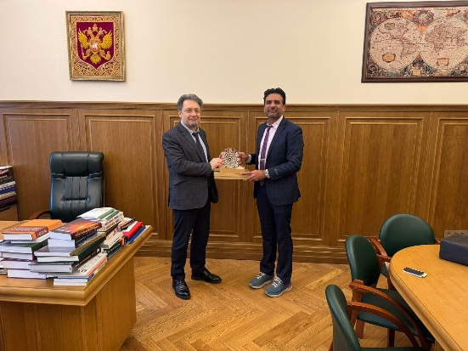
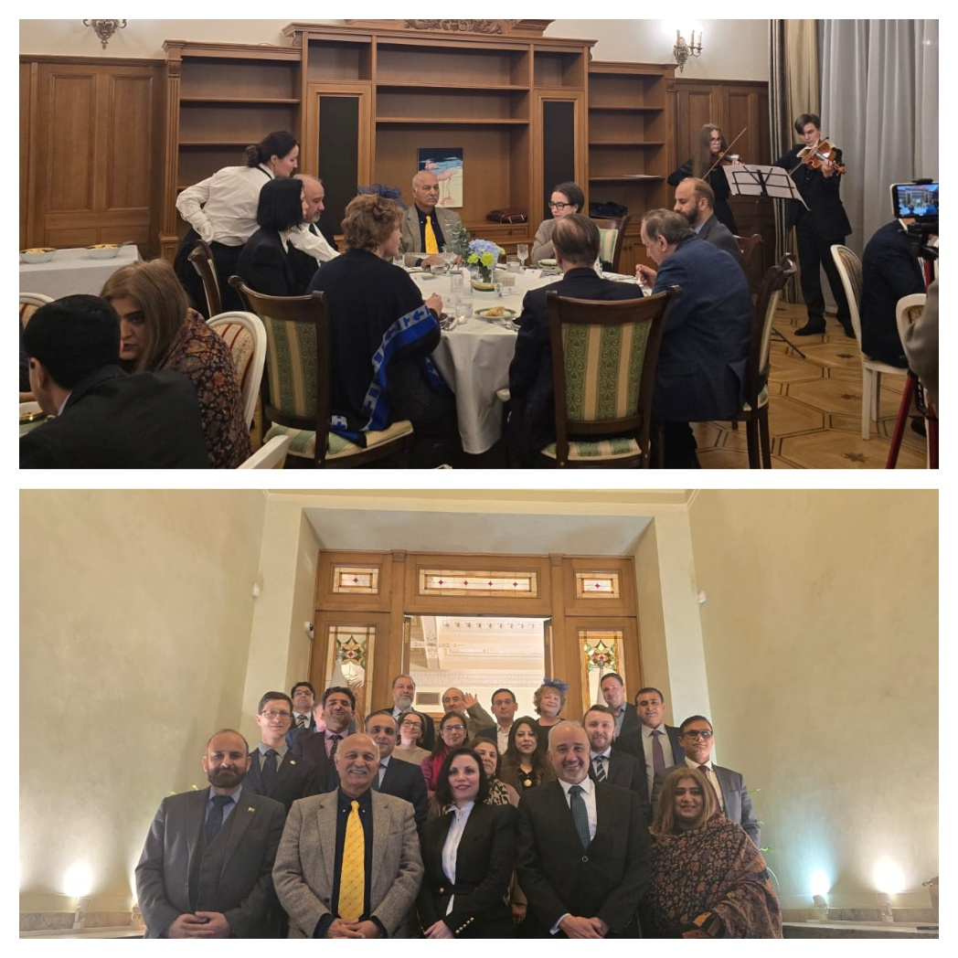
Meeting with Director and Deputy Director of Institute of Oriental Studies, Russian Academy of Sciences
MoU Signing Ceremony

